The RSAT tool was released only for windows 8 Preview, however it can be installed on windows 8 RTM.

Download the msu package - Windows6.2-KB2693643-x64  (link: <http://www.microsoft.com/en-in/download/details.aspx?id=28972>)

If you execute the file directly you will see this error:

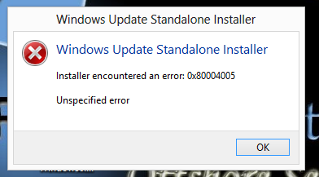

Open the command prompt (run as administrator) and change the directory to where the package is stored, in my case I had placed the .msu file on my desktop.

Execute the below command:

expand -F: \* Windows6.2-KB2693643-x64.msu C:\ rsat   (note that I had to create the rsat folder before expanding). You can use winrar or 7 zip to extract the .msu file.

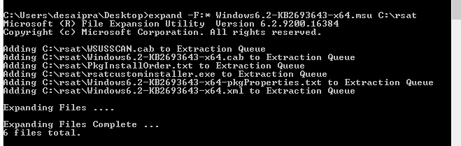

Change the path to folder where the extracted files are and execute the command : pkgmgr /ip /m:Windows6.2-KB2693643-x64.cab

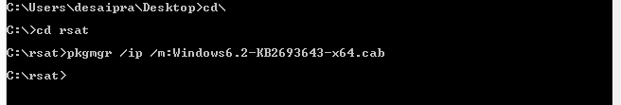

Wait for few minutes this will be a silent installation. After few minutes you should find the tools installed.

